ASSIGNMENT 5
1. i. What is system call?
-> A system call is a way for a user-level program to request services from the operating system kernel.
It acts as an interface between the process and the OS.
ii. Briefly demonstrate fork() system call, and its working principle.
-> fork() is a system call used to create a new process, called the child process, which runs concurrently with the parent process.
Both parent and child start executing the next instruction after the fork() call.
Working Principle:-
When fork() is called:
The OS creates a duplicate of the current process.
Both processes (parent and child) have the same code, but different process IDs (PID).
Return values:
In parent process → returns PID of child (positive number)
In child process → returns 0
On failure → returns -1
2. i) Write a program in C, which will illustrate the fork() system call and getpid()
system call.
CODE:-
#include <stdio.h>
#include <unistd.h>
int main() {
int pid;
pid = fork(); // create a new process
if (pid < 0) {
printf("Fork failed!\n");
}
else if (pid == 0) {
// Child process
printf("This is the child process.\n");
printf("Child PID: %d\n", getpid());
printf("Parent PID (from child): %d\n", getppid());
}
else {
// Parent process
printf("This is the parent process.\n");
printf("Parent PID: %d\n", getpid());
printf("Child PID (from parent): %d\n", pid);
}
return 0;
}
OUTPUT:-
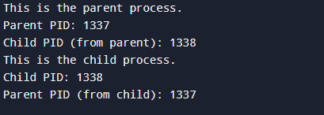
ii. Write a program in C, which will copy your name, roll number and department name exactly 8 times, by using fork() system call.
CODE:-
#include <stdio.h>
#include <unistd.h>
int main() {
fork();
fork();
fork();
printf("Name: Annixiki Biswas | Roll No: 123456 | Dept: CSE (AIML)\n");
return 0;
}
OUTPUT:-
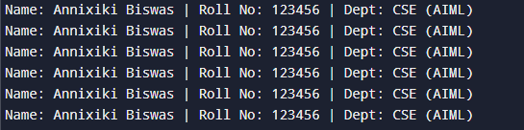
iii. Write a program in C, which will illustrate wait() system call.
CODE:-
#include <stdio.h>
#include <unistd.h>
#include <sys/wait.h>
int main() {
int pid;
pid = fork();
if (pid == 0) {
// Child process
printf("Child process running... PID = %d\n", getpid());
sleep(3); // simulate some work
printf("Child process finished.\n");
}
else {
// Parent process
printf("Parent waiting for child to finish...\n");
wait(NULL); // waits for child
printf("Parent continues after child completion.\n");
}
return 0;
}
OUTPUT:-
